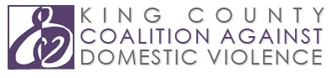

The Domestic Violence and Mental Health Collaboration Project

The King County Coalition Against Domestic Violence coordinates this project to improve services for survivors of domestic violence with mental health concerns. We are working collaboratively to enhance the knowledge and skills of domestic violence advocates and mental health service providers in order to make services more accessible, holistic, and effective. Our partners are: Consejo Counseling and Referral Service, New Beginnings, Seattle Counseling Service, and Sound Mental Health.

The Project has had three phases: Planning, Implementation, and Continuation.

Phase 1: Planning Phase (2007-2009)

Phase 2: Implementation Phase (2009-2010)

Phase 3: Continuation Phase (2011-2012)

*These publications and our online courses are available at www.kccadv.org/reports/mental-healthdv-reports/.

This project is supported by Grant No. 2010-FW-AX-K007 awarded by the Office on Violence Against Women, U.S. Department of Justice. The opinions, findings, conclusions, and recommendations expressed in project publications are those of the authors and do not necessarily reflect the views of the Department of Justice, Office on Violence Against Women.

1419 S Jackson St, Suite 103, Seattle, WA 98144 ⎜ 206.568.5454 ⎜ www.kccadv.org

