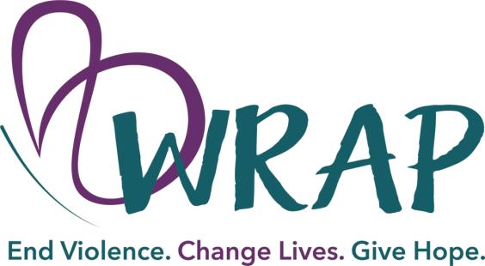

ATTN: JMCGH ER NURSE OR SANE
Please inform the patient that WRAP services are available to anyone who has been sexually assaulted. These services are voluntary, free, and confidential.
We ask that during this time you provide the folder attached to this sheet and ask the patient the following questions and provide their responses to the advocate when you contact the WRAP hotline at 1-800-273-8712.
- Would you give me verbal permission to contact WRAP on your behalf?
(If the patient answers no, please give them a WRAP brochure and encourage them to contact us at a later date. If the patient answers yes, proceed with these additional questions.)
- Do you have a support person with you (family, friend, etc.)?
- What county do you reside in?
- Do you have a safe place to go upon discharge? (If the patient answers no, please communicate this to the hotline responder).
- What is a safe phone number for you to be reached?
- When would you like to be called by a WRAP advocate?

