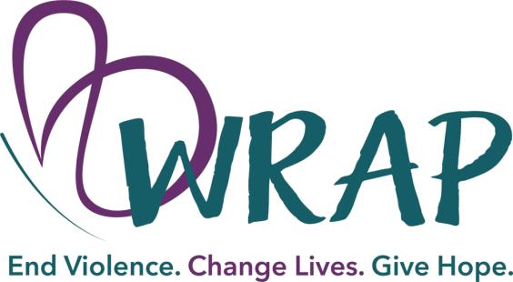
We want you to know that WRAP is here to help you as you recover from this distressing experience. We have a number of ways in which we can help you, but please understand that it is your choice which services you choose to access.
Our services are always free and always confidential. We will not talk to the ER staff, law enforcement, your family or friends without your written permission. That being said, here are some of the services that you may want to receive:
- For your immediate needs, safety planning is needed-we want to be sure you have somewhere safe to go after you leave the emergency room. You may also want to speak with us about getting an order of protection.
- Counseling-you may experience a number of physical and emotional reactions. Talking with someone who understands this kind of trauma can help.
- Accompaniment-if you choose to make a report to law enforcement, you may want a WRAP advocate to be present with you to offer emotional support. We also provide accompaniment to court.
- Therapy-a traumatic event can present you with the need to see someone who can help you heal from the trauma. Our therapists use proven treatment models.
- Most importantly, we can offer you support and understanding. We don’t want anyone who has experienced sexual assault to think that they have to “just go on like nothing happened.” Having contact with one of our advocates can give you that much needed support.
- 24 hour crisis line-someone from WRAP is always available when you need to talk. That number is 800-273-8712.
If you want us to follow up with you, please know that we will do that at a time that is convenient for you. We know you need to rest, so tell us when you want us to contact you and we will give you a call. From there we can make an appointment to meet you in person.

